**Dynamo DB**

It is Based on NoSql. It offers customers high-availability, reliability and incremental scalability with no limits on dataset size.

LAB:

Create a Table

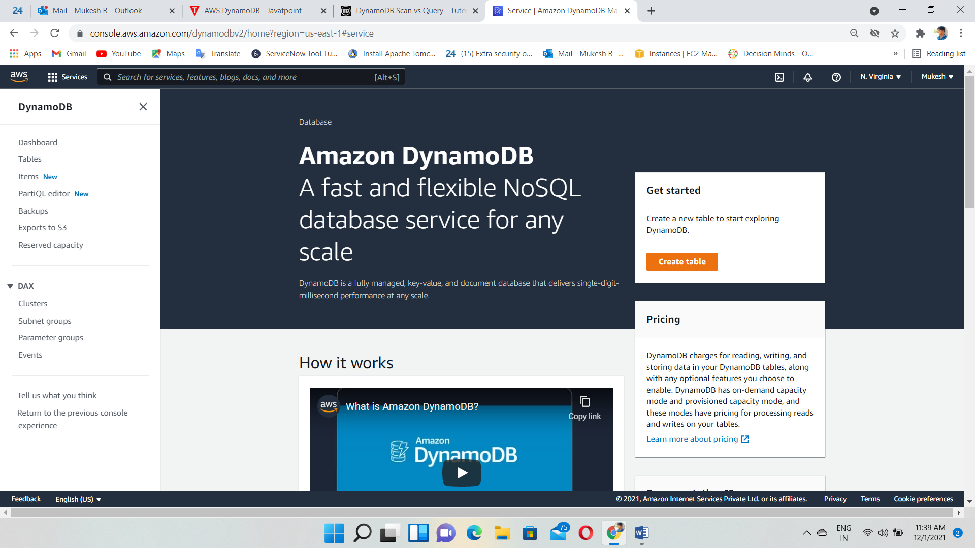

Give a Name for Table and Partition Key

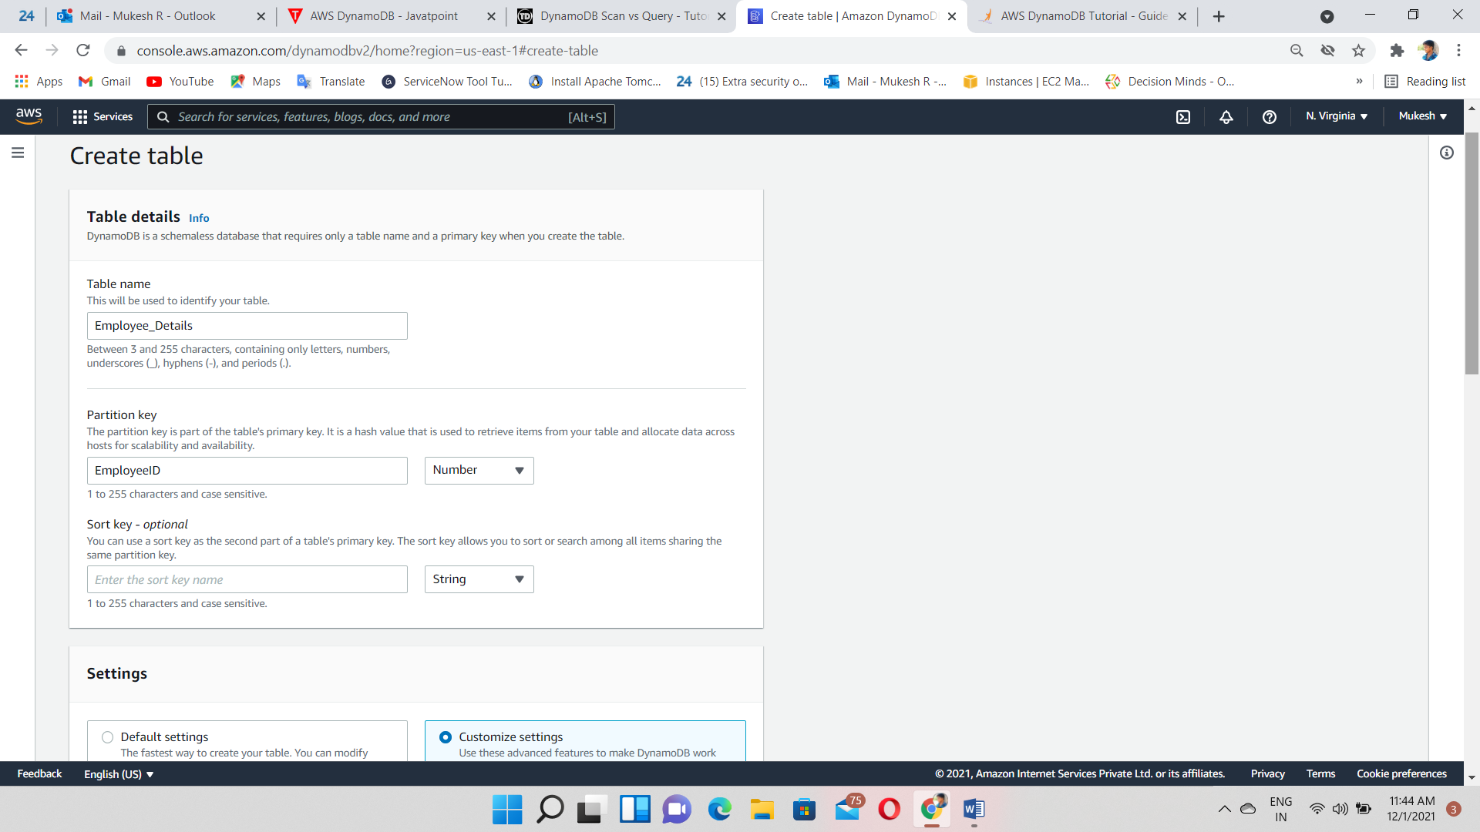

Select On-demand for demo

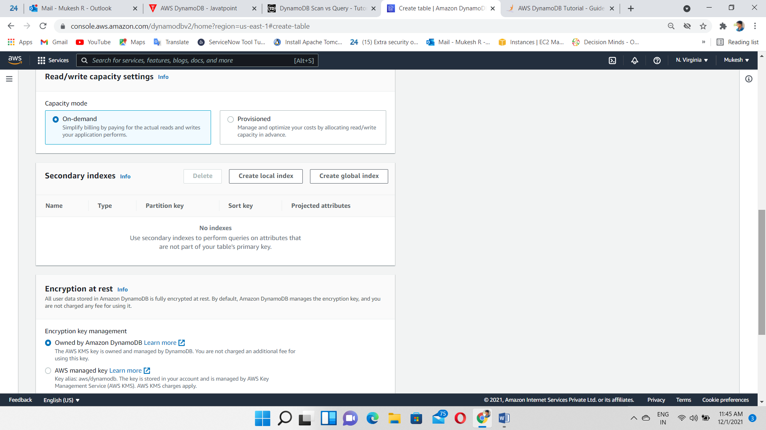

Table Created

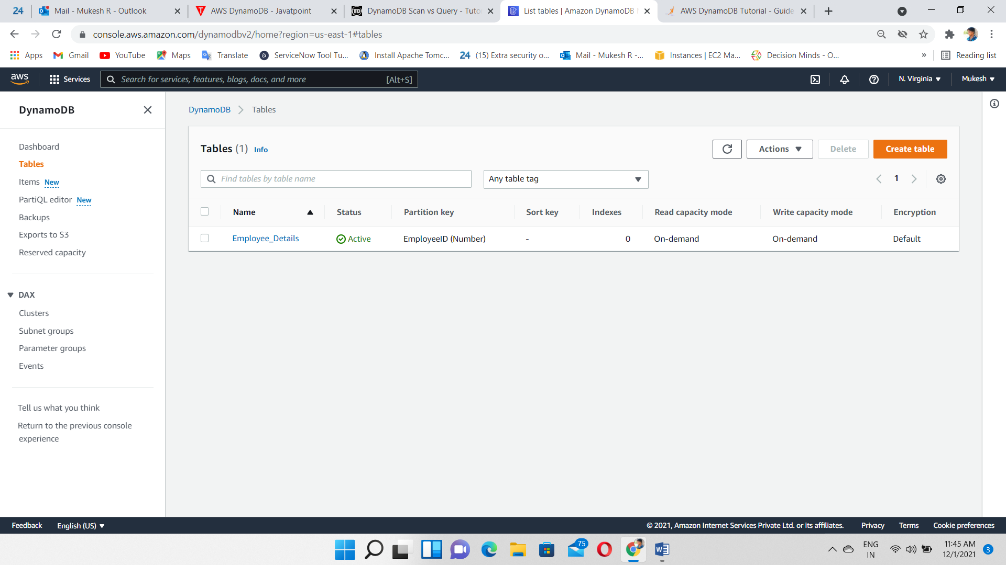

Click on overview to get all the information about the Table

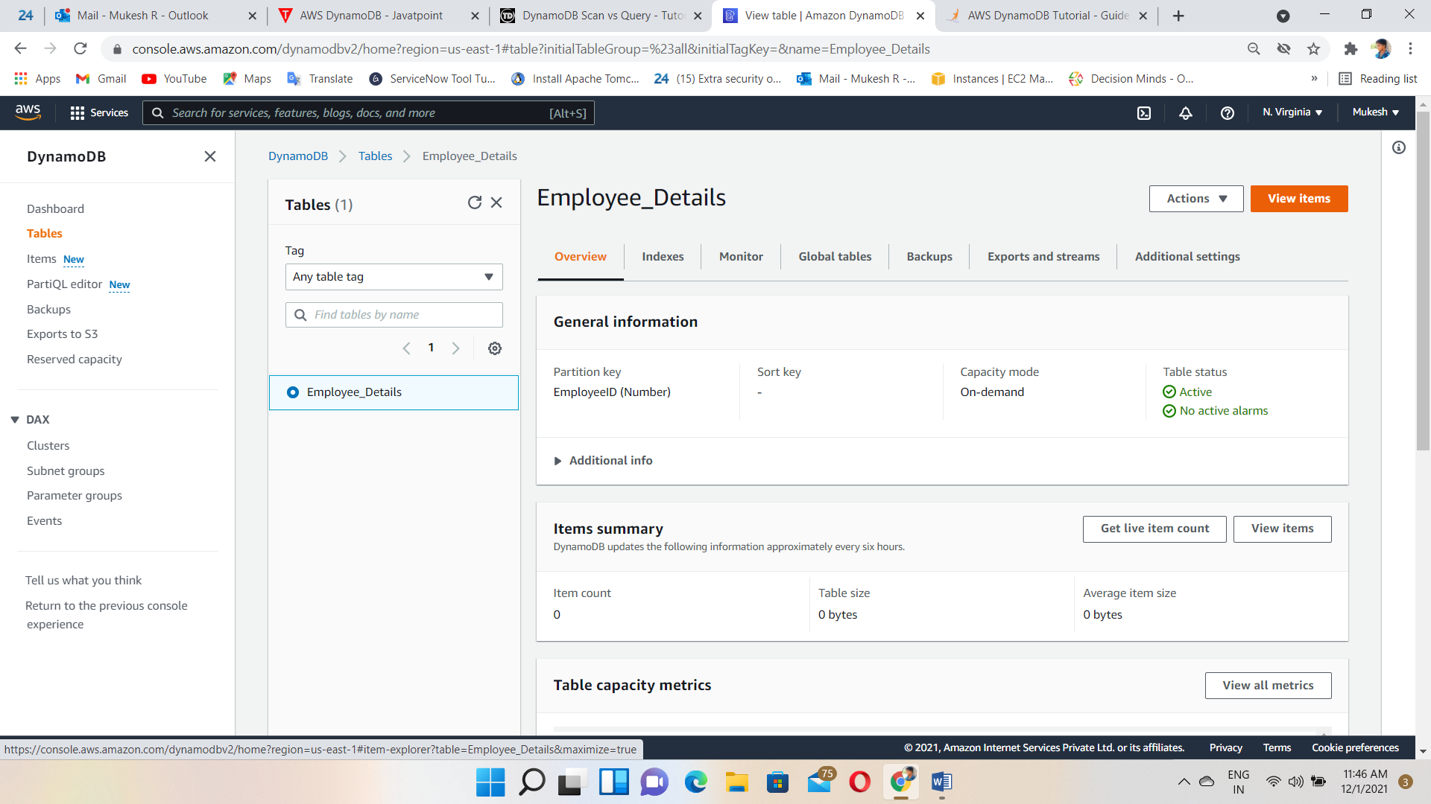

Click on Create Item

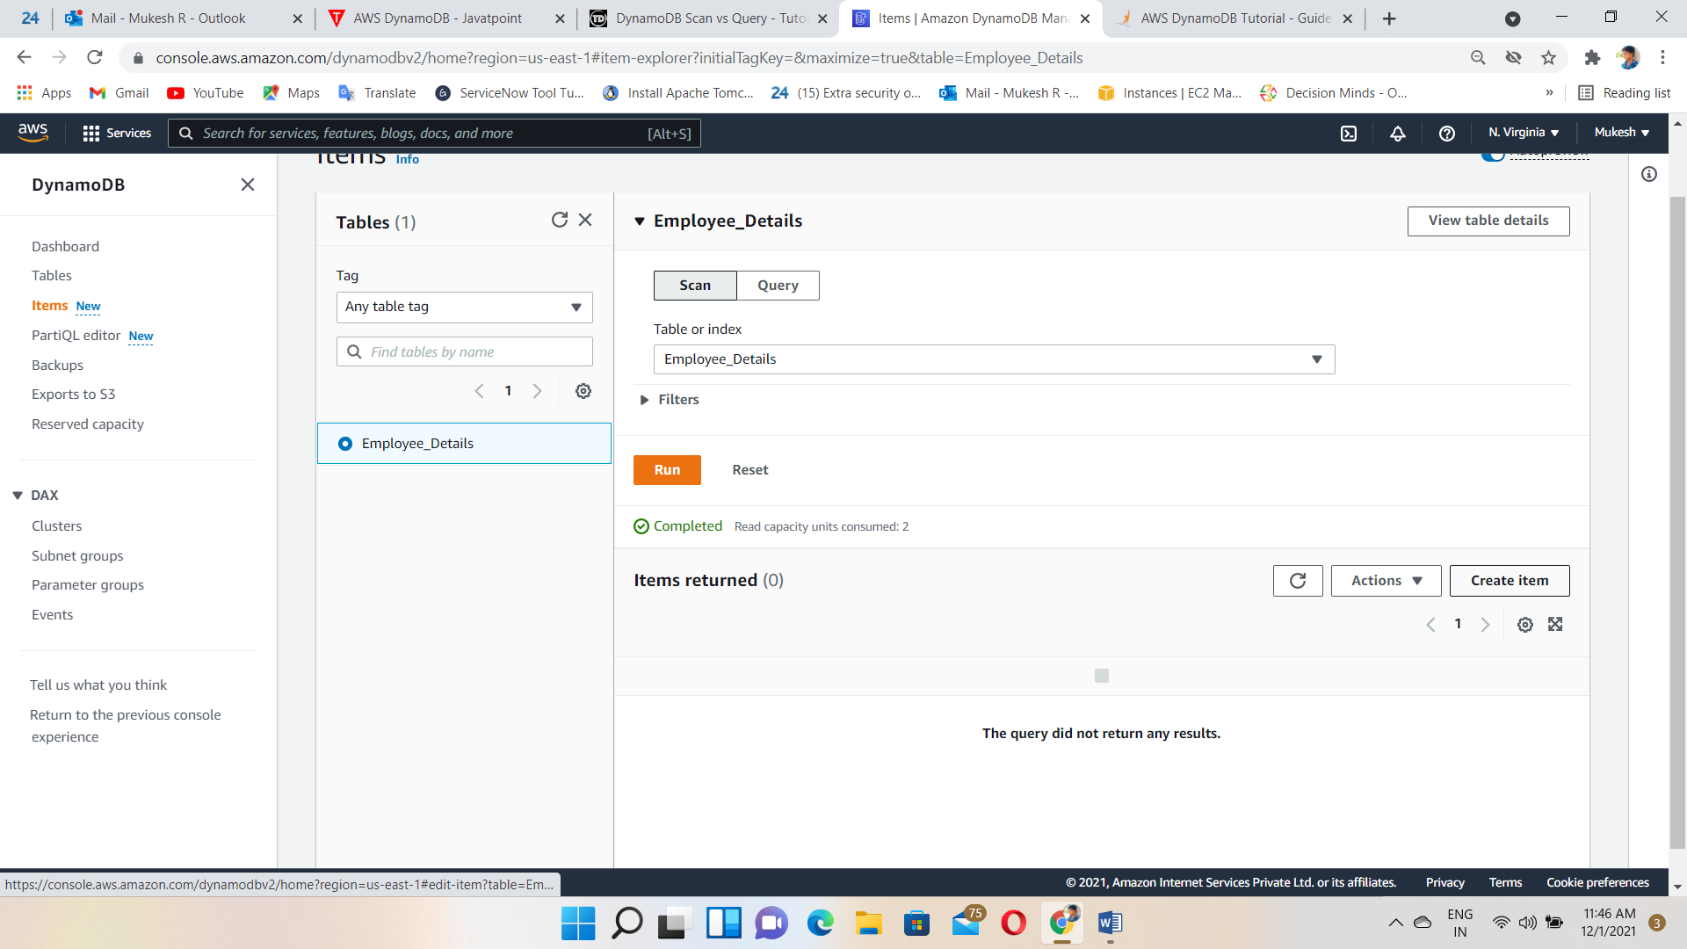

Add data’s we want

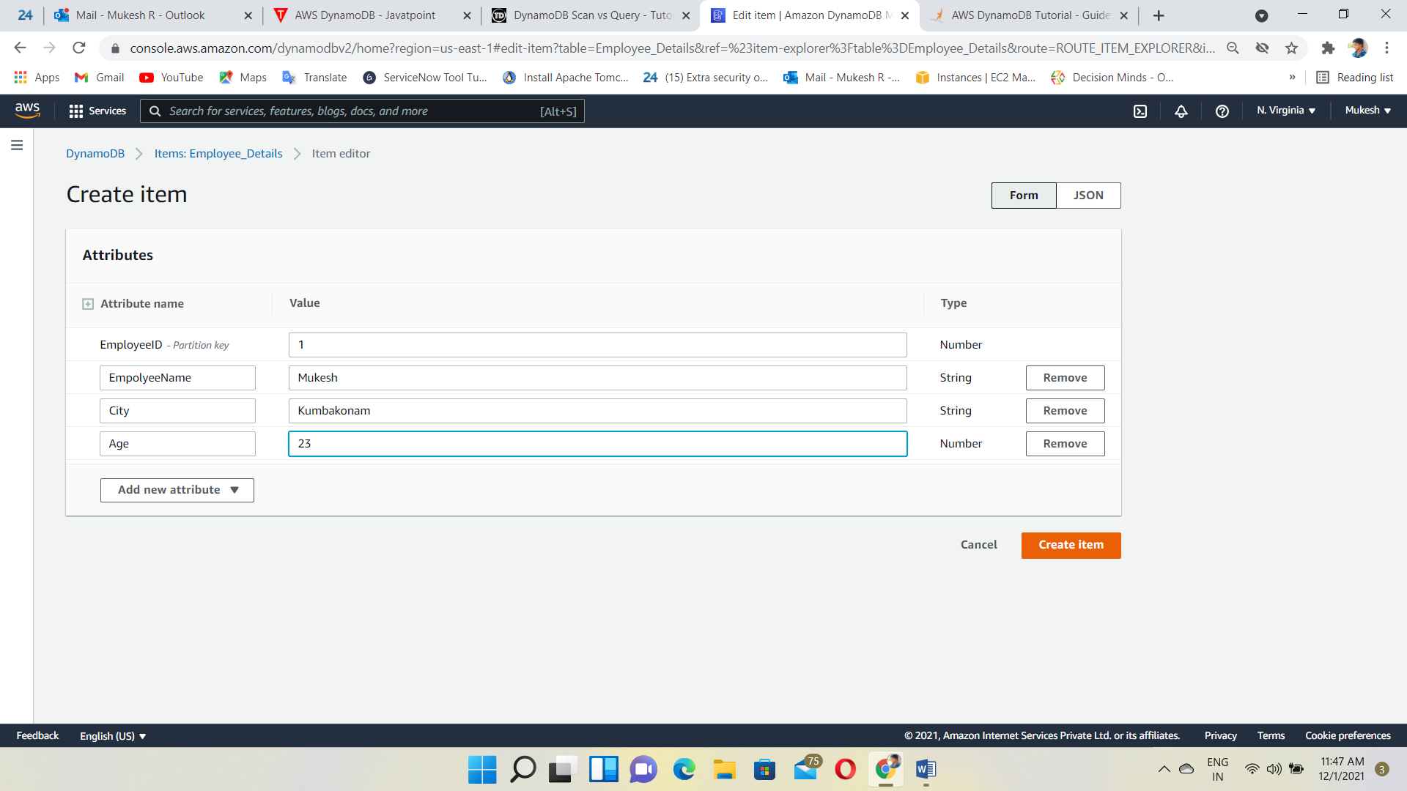

Add one more data’s

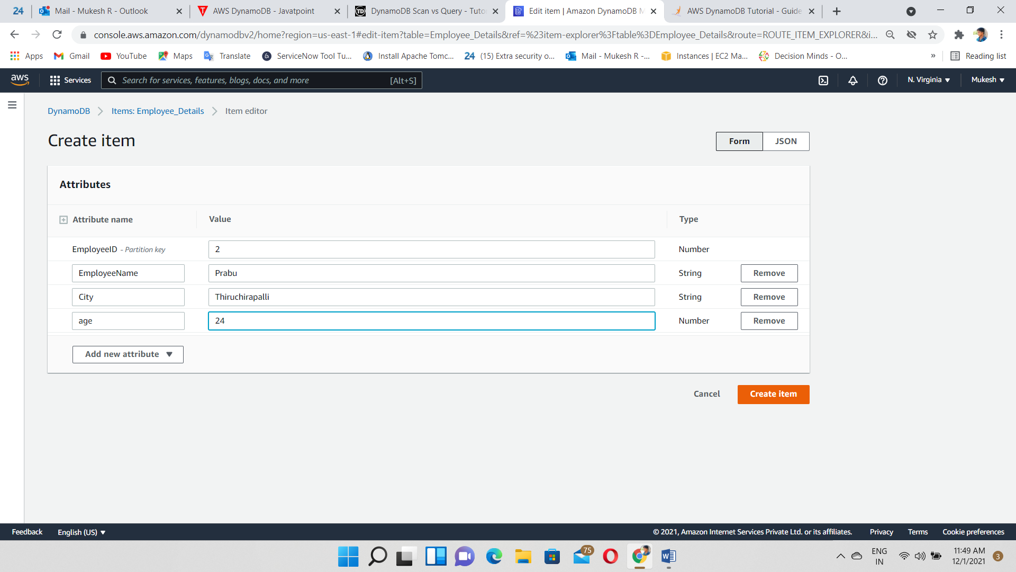

Items created

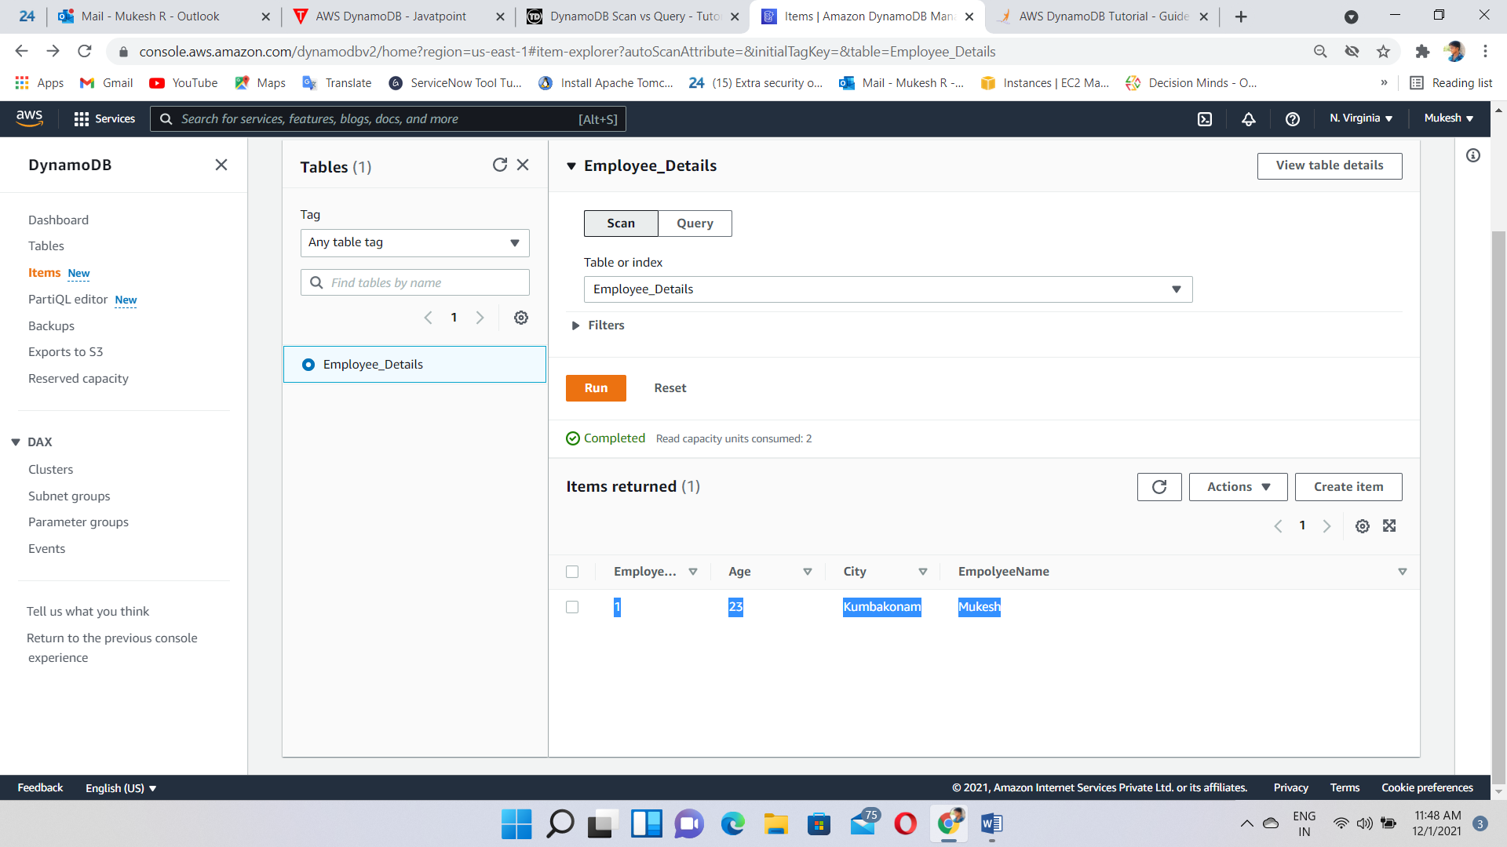

Now,let us do some simple scan(or)querying

filter “City=Kumbakonam”

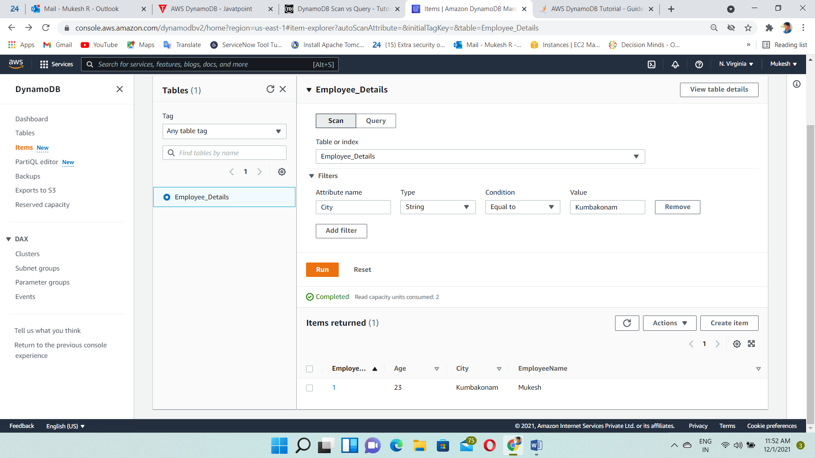

PartiQL Editor

It supports like Sql language for querying, modifying and inserting the data.

Select * From Employee_Details Where EmployeeID; 🡪Sql Command

